

As our very own Stephanie Robertson once suggested, we all need to Spoke up! In all seriousness, Spoke up is going to be a really good event which you all should make your way down to, it’ll be a day out for the whole (Bruce) family! Even though exams are coming up, it would be great day for everyone to get out and about, have some fresh air, and for most of us, see a side of Canberra you haven’t seen before!

*Doing it for Bill since 2014*

THE BRUCE BILLITIN

**ISSUE 12: Monday 9th May – Sunday 15th May**

*Doing it for Bill since 2014*

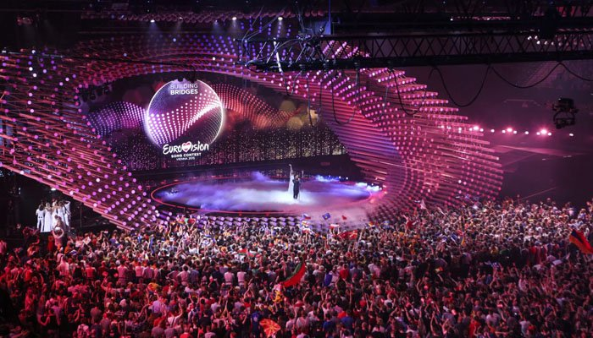

FESTIVAL OF AMBITIOUS IDEAS  
**Brindabella Conference Centre 12th May 2016**

Running all day is this festival focused around looking at the idea of “Future Cities” and how we are going to deal with overpopulation and overcrowding in the future. There will be several speakers presenting throughout the day, each an expert in their own field.

YO FUNKY DANCE FESTIVAL

**Woden Youth Centre 13th May 2016 6pm**

A free community event with a name worthy of an Earth, Wind and fire commemorative album, this event takes dance from the halls to live venues. With dance battles, freestyle dance and other great performances come to this one if you want to feel like you’re on the set of a Step up film (the Billitin takes no responsibility for any disappointment regarding a lack of Channing Tatum).

EUROVISION SUPERFAN PARTY

**National film and Sound Archive 15th May 2016 5:30pm**

In association with SBS and the embassy of Sweden, here’s an event for all of you who have an ABBA costume tucked away, a beard ready to be put on, and can be found in transit loudly belting karaoke. There will be a (delayed) live-feed from the finals, euro-centric karaoke, bingo and a Swedish centric theme! Admission is free, but head to [www.nsfa.gov.au/calendar/event/](http://www.nsfa.gov.au/calendar/event/) to book a ticket.

CAPITAL REGION FARMERS MARKET  
**Canberra Exhibition Park 14th May 7:30-11:30am**

Sample the region’s freshest produce at the Capital Region Farmers Market, held from 7:30 to 11:30am every Saturday. There are over 100 stallholders, all with their own freshly picked and handcrafted produce. If you’re not feeling hungry yet, you may just be a lost cause, but if you are, then make sure to catch this at least once while you live in Canberra.

Eurovision. An event which to win is almost more of a burden than a benefit.

MENTAL HEALTH IN HIGHER EDUCATION SYMPOSIUM  
**9th May 9:30am-3:30pm Australian Centre on China in the World, Lotus Hall**

An event run by ANUSA, PARSA and ANU aimed at introducing the student community to mental health and how it impacts our lives in university. This will take place through addresses from keynote speakers, as well as workshops on key issues within mental health, including; the impact of online harassment, cultural diversity and mental health, and the role of peer support in mental health.

ANU & POLICY FORUM 2016 FEDERAL ELECTION SERIES  
**10th May 6pm, Molonglo Theatre JG Crawford Theatre**

Join the ANU community at a weekly panel at which experts discuss a different public policy issue every week until the election. This week, they will focus on a no holds barred overview of the election, looking at the policy, politics and predictions for this year’s election.

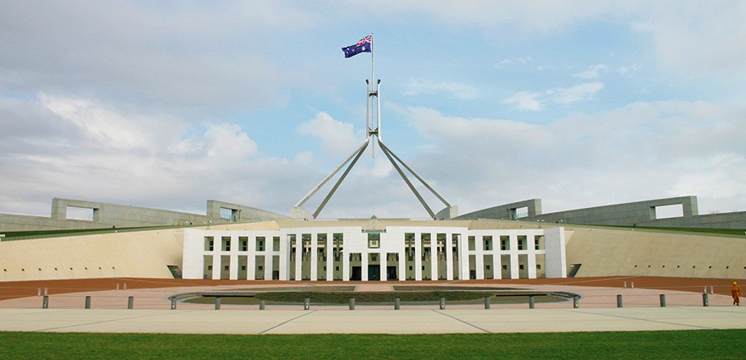

*To the World you may be one person, but to one person you may be the World* – Bill Wilson



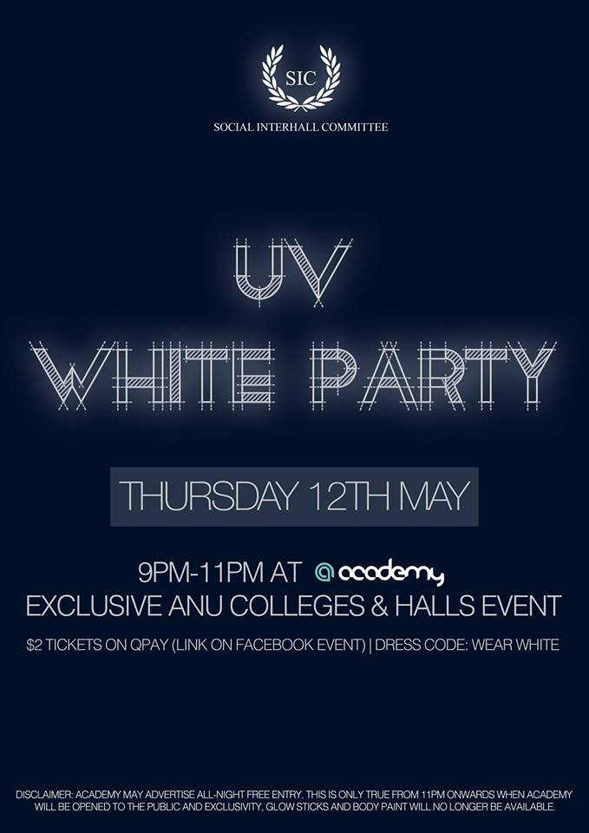

SPOKE UP: ANU Rides to Smash the Stigma

**Sunday 15th May 8am -5pm Stromlo Forest Park**

You’ve heard about on Banter, Ressies, in Puff, through speeches, and now it’s only right the Billitin add its own touch to promoting this wheelie awesome event.

Spoke up is an event which will take place over the course of this Sunday. Every college is invited, and everyone can get there either through driving, or cycling. Riding is preferable, as this earns us more points as a college.

This event is designed for riders of all skill levels, with races, bike parades and mountain biking, as well as those who don’t ride, with a BBQ, Frisbee and even a music festival. Essentially there is something for everyone, and therefore, no excuse to miss it!

The focus of this event is on raising money for Batyr, and to support an open and positive discussion about mental health at ANU. Mental health is an issue which will affect everyone at some point in their lives, and one we need to be aware of. Furthermore, we can also get more cashmoney’s for our own college events, so really what is their not to like?

To get involved, you simply need to sign up on the google document available on the Facebook page for this event (which is titled ‘ANU SPOKE UP’) if you would like to cycle, volunteer or perform. This event is open to all ANU students, alumni and staff, and there is a pool of prize money up for grabs, which is split depending on how many people from our college participate.

If you have any more questions, don’t hesitate to ask our glorious leader Kat’tain Throssel.



TRIVIA

1. When was the last time, other than this year, that a double 6. Joseph Smith was the founder of what religion?  
 dissolution election was called? 7. In what year was the iPhone first released?

2. What were the odds on Liecester City winning the British 8. How much caffeine can you drink a day before it becomes  
 Premer League at the season’s beginning? A safety concern?

3. What country could you rent for a night for $70 000? 9. Which country invented the fortune cookie?

4. What is a baby swan called? 10. How old is David Attenborough?

5. In what decade was the M&M first introduced?

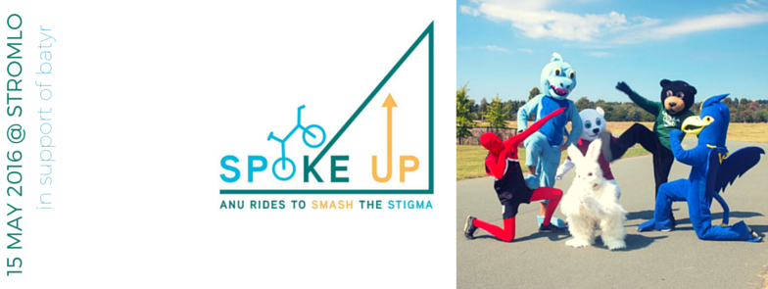

1. 1987, 2. 5000 to 1,3. Liechtenstein, 4. A cygnet, 5. 1940’s 6. Mormonism, 7. 2007, 8. 400mg (about four shots) 9. America, 10. 90  
Riddle answer: A keyboard

RIDDLE ME THIS

I have keys but no locks.  
I have a space but no room.  
You can enter, but can’t go outside  
What am I?

SPORT

We have plenty of sport this week for all of you, meaning that we need to get lots of you down to support the teams that are playing. Game times are as follows:

**Mens Hockey:** 11:30am

**Women’s Hockey:** 1:30am

**Frisbee:** 11am at Spoke Up.